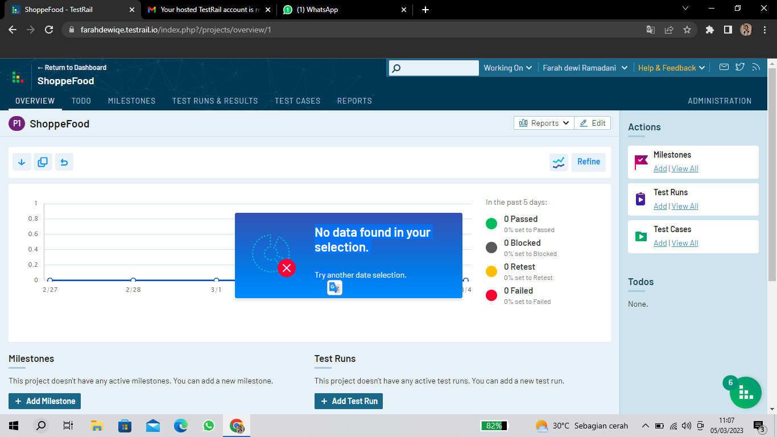

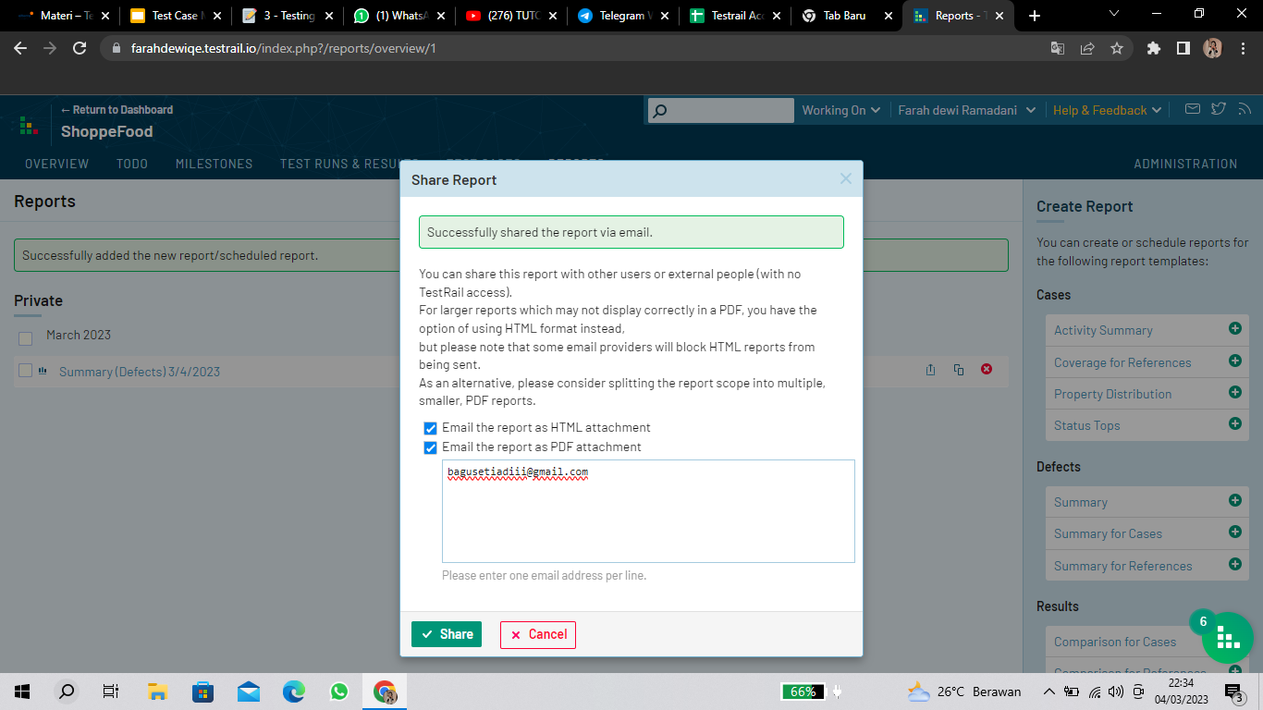

https://docs.google.com/document/d/10pP8WOYraRgChoziU45RecDUSVcwR67oqLSrisJ4S3g/edit?usp=sharing